Griswold
Challenge

Exciting Prizes for the Best Lights & Decorations!

For $100 your team will receive a 10x20 space to decorate for the 2nd annual Griswold Challenge. The winner will receive half of the entrance fees for winning. For example, if 10 teams compete the prize money for the winner will be $500 because (10x$100) * 50% = $500. The more teams that compete the larger the prize money becomes!

Judging will take place during the event through a People’s Choice contest. Teams are encouraged to engage spectators, invite friends and family to vote, and use a wide variety of social media tools to encourage people to come down to Victorian Square to vote. Team members are not allowed to vote.

Those who’d like to enter the contest should fill out this form and submit a $100 check payable to 39 North. Please mail entry form to LoKa Tile / 39 North, 972 E. Greg Street, Sparks, NV 89431.

All entry forms and registration fees must be received by December 1, 2017.
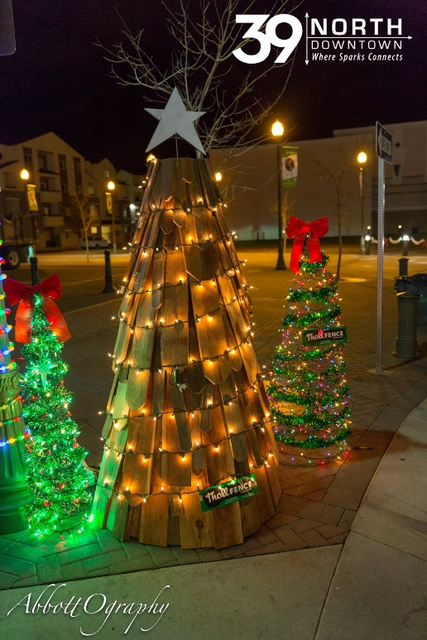
Contact Person: ___________________________________
Team Name: _____________________________________
Address: _________________________________________
Phone: __________________________________________
Email: ___________________________________________

I give 39 North Downtown permission to use my name and team name in any promotion or announcement concerning this contest. I give permission for photos to be used for future event advertising.

Signature: ________________________________________
Date: _____________________
Griswold
Challenge

Rules, Regulations and Procedures

Load in / Display Build: 9:00 a.m. to 3:00 p.m. Thursday, December 7

Teams are encouraged to be creative, use unique design, and as many holiday decorations and lights as possible.

Helpful Items to bring:
- Decorations
- Extension Cords
- Lights
- Zip ties, scissors, and duct tape

Decorations, special sound effects, fog, animation, and team spirit are highly encouraged!

Contest Rules:
- The entry form and liability release form must be received no later than December 1st.
- All participants must sign a liability release and hold harmless form.
- Each entry must be contained in a 10 x 20 space.
- Entry must be weighted down and built to withstand tough Nevada winter weather conditions.
- Entry must pass fire inspection. No frayed cords or fire hazards.
- Each entry must display their entry number and team name. Sign provided by event producer.
- Entry number and team name must be displayed on the right front of your display. This is to help spectators vote for the best displays.
- There will be NO early tear downs. All displays must be removed by 3:00pm Sunday.
- Absolutely no throwing items (candy or toys) from display area. You may hand out candy and holiday swag.
- Voting ends at 7:00p.m. Saturday and winners will be announced when the event closes before 9:00 p.m.
- People’s Choice votes are final.

Don’t forget to submit your registration form by December 1, 2017

